# Lab 10.1 Develop the Clock application

In this exercise, you’ll create an application that displays the current time in hours, minutes, and seconds. The display should use a 12-hour clock and indicate whether it’s AM or PM. The application looks like this:

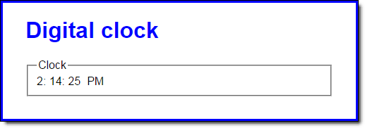

To convert the computer’s time from a 24 hour clock to a 12 hour clock, first check to see if the hours value is greater than 12. If so, subtract 12 from the hours value and set the AM/PM value to “PM”. Also, be aware that the hours value for midnight is 0.

1. Open the HTML and JavaScript files in this folder:

lab9\clock\

1. In the JavaScript file, note that four functions are supplied. The $ function. The start of a displayCurrentTime function. The padSingleDigit function that adds a leading zero to single digits. And the start of an onload event handler.
2. In the displayCurrentTime function, add code that uses the Date object to determine the current hour, minute, and second. Convert these values to a 12 hour clock, determine the AM/PM value, and display these values in the appropriate span tags.
3. In the onload event handler, code a timer that calls the displayCurrentTime function at 1 second intervals. The timer should run when the page loads.